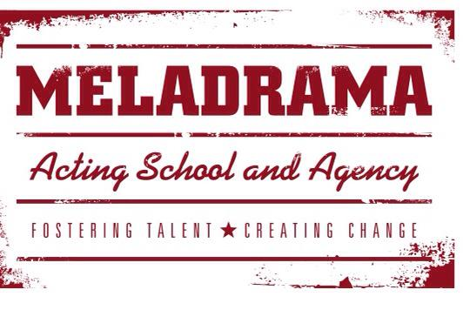
Student’s name…………………………………………………………………………………………………
Students date of birth and current age……………………………………………………………..
3 forms of identification provided and copied and signed by Melanie Ash (1 photographic)
1)………………………………………………………………………………………………………………………
2)………………………………………………………………………………………………………………………
3)……………………………………………………………………………………………………………………..

Have you any criminal convictions relating to violence or sexual abuse?
……………………………………………………………………………………………………………………………………………

Have you ever been investigated due to an allegation relating to sexual or physical abuse against children or vulnerable adults?
……………………………………………………………………………………………………………………………………………

Are you known to child protection teams in the local authority or across the UK?
……………………………………………………………………………………………………………………………….
PLEASE TICK BOX AND SIGN
I give permission for Meladrama to use this information to check my identity against the electoral roll.
I give permission for Meladrama to ask for clarification from relevant authorities in line with their safeguarding policy if required and with my prior consent.
I support Meladrama’s safeguarding policy and declare that I won’t contact any students that are under the age of 18 or vulnerable outside of class.
SIGNED………………………………………………………. DATE………………………………………………………………

