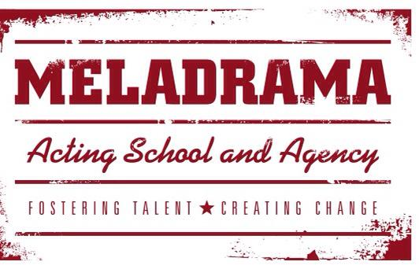
Student’s name…………………………………………………………………………………………………
Students date of birth and current age……………………………………………………………..
Students or responsible adults
telephone number (mobile)……………………………………………………………………………….
E mail address for scripts,
information about shows etc……………………………………………………………………………..
Anything else you want us to know about you? Anything we can do to support you in your tuition? For example dyslexia, epilepsy, asthmatic, learning difficulties etc (please give as much info as possible) …………………………………………………………………………………………………………………………………………………………………………………………………………………………………………………………………………………………………………………………………………………………………………………………………………………………………………………………………………………………………………
Responsible adult to call in an emergency. Mobile and home telephone numbers, address and a 2^{nd and/or} emergency contact number
……………………………………………………………………………………………………………………………………………………………………………………………………………………………………………………………………………………………………………………………………………………………………………………………………………………………………………………………………………………………………
ADULT/YOUNG ADULT/TEENAGE CLASSES If over the age of 18 please provide 3 forms of ID (1 photo) to be copied and witnessed by Mel. Speak to Mel direct for more information. If over 18 we request you do not contact other students under the age of 18 via text, e mail, social media, telephone or other electronic communication. Questions about rehearsals/scripts etc can be posted on the private group page (monitored by Mel). A copy of our safe guarding procedures is available on request. All staff (including teaching assistants) have full up to date DBS checks and are regularly trained in child protection and safe guarding.
3 SEPARATE ID PROOF PROVIDED & COPIED…………………………………………………………………DATE……………………
www.facebook.com/meladrama @MELADRAMAUK

